Tchoukball
History
The game of Tchoukball was named after the sound the ball makes when it rebounds off the frame. It was invented by Dr. Herman Brandt, a Swiss biologist who was disenchanted with the “win at all cost” mentality of modern sport. He wanted to invent a new game that would promote teamwork and instill a love of play including players of all skill levels.
How to play Tchoukball?
To play tchoukball, two official tchoukball rebound surfaces and a Tchoukball ball are needed. The game is played on a handball court (20X40 meters, or about 66 feet by 132 feet) between two teams of nine players or on a basketball court between teams of six or seven players. The rebound surfaces (which can be used by both teams) are placed at each end of the court, and each one is within a semi-circle line, with a three-meter (9.9 foot) radius, which defines the forbidden zone.
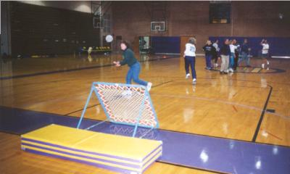
The team that has possession of the ball has a three-pass limit before being forced to shoot the ball at the rebound surface on either end of the court. Members of the other team must place themselves according to where they expect the ball to land, so that they can catch it before it touches the floor. Meantime, members of the other team look to position themselves to recover the ball after it rebounds from the rebound surface, before the ball can touch the floor. During the course of the game, the players of each team are not allowed to interfere with players of the other team: they may not intercept passes, interfere with the movements of the person carrying the ball or his teammates, or stop a defender from positioning himself to catch the ball after the rebound.

Scoring
A player scores a point for his team if he bounces the ball off the rebound surface in such a manner that it cannot be caught by an opponent before it touches the floor.
A player gives a point to the other team if:
- He misses the rebound surface when he shoots the ball.
- He makes the ball bounce out-of-bounds
- He shoots the ball and it bounces back, touching him.
- He sends the ball into the forbidden zone, before or after it hits the rebound surface.

Penalties
A player commits a penalty if:
- He moves while dribbling the ball on the floor or juggling it in the air.
- He takes more than 3 footprints on the floor while in possession of the ball.
- He plays using parts of his body below his knees.
- He makes a fourth pass for his team.
- He makes contact with the floor out-of-bounds or in the forbidden zone while holding the ball.
- He drops the ball after it is passed to him.
- He voluntarily, or by error, catches a pass from the other team.
- He catches a ball off of the rebound surface that was shot by one of his teammates.
- He blocks his opponents from moving or stops them from freely passing the ball once they have gained possession.
After a penalty, the ball is given to the other team and the game continues from the spot where the penalty was committed. A pass must be made before throwing the ball at the rebound surface.
If the ball hits one of the edges of the rebound surface and the path of the ball is changed, the team may not receive a point. This is a penalty and the game continues from the spot where the ball hit the floor. The ball is given to the team which was defending at the time of the penalty.
In a “bipolar” game (with two rebound surfaces), it is illegal to shoot the ball more than three consecutive times at the same rebound surface.
A player must throw the ball in-bounds from behind the base line, next to the rebound surface. This throw does not count as one of the team’s three passes.

Technical information
The Court and the Players
 | Size of the Court | Number of Players | Length of Time
1st Solution | 132 x 66 ft | 9 Players / Team | Men: 3 x 15 min  Women / Mixed : 3 x12 min
2^{ns} Solution | 66 x 36 ft | 7 Players / Team

Materials needed
- one Tchoukball ball
- two rebound surfaces (3,3 ft x 3,3 ft frame with 55-degre incline)
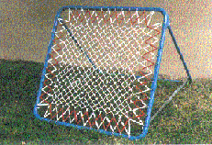
The rebound surfaces are placed at the opposite sides of the court.

Specials Zones
- In front of each rebound surface is a semi-circle with a three-meter (9.9 ft) radius, which is called the forbidden zone. A player may not be in the forbidden zone unless he has just shot or passed the ball. Either case, the player's feet may not in the forbidden zone if the ball is still in his hands.
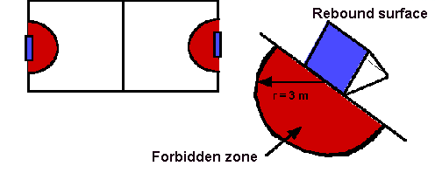

Objectives
- For the team that has possession of the ball: throw the ball off the rebound surface after a maximum of three passes. After the ball hits the surface, the ball must touche the floor outside of the forbidden zone to score a point. If the other team catches the ball before it hits the floor, neither team scores and the game continues.
- For the defensive team: catch the ball after it has hit the rebound surface and before it touches the floor. To do this, each team member must constantly place himself according to the offensive team's passes. It is illegal to intercept the ball or to interfere with your opponent.

Particular rules
- There are no designed sides (each team may shoot the ball at either rebound).
- It is illegal to intercept a pass from the other team.
- No more than three passes before shot.
- no more than three steps by a player holding the ball.
The rules of 3

3 seconds to play the ball
3 passes
3 steps with the ball
3 attempts at the same goal (both teams)

2013 Tchoukball Inc. All rights Reserved

